Exercise 2 :

A chocolate bar featuring a map it looks like a hidden story.If you focus on the it , you will see a detail phrase “DO IT RIGHT” printed in the top-right corner.

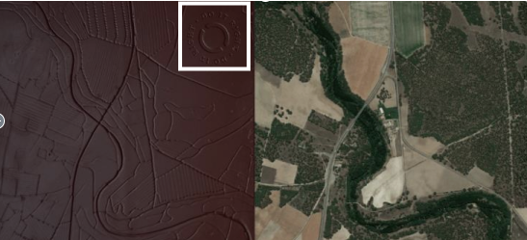

Out of Curious, we did reverse image search of the chocolate on Google. We discovered it was made by Puchero, a brand known for using similar slogans and map-themed packaging.

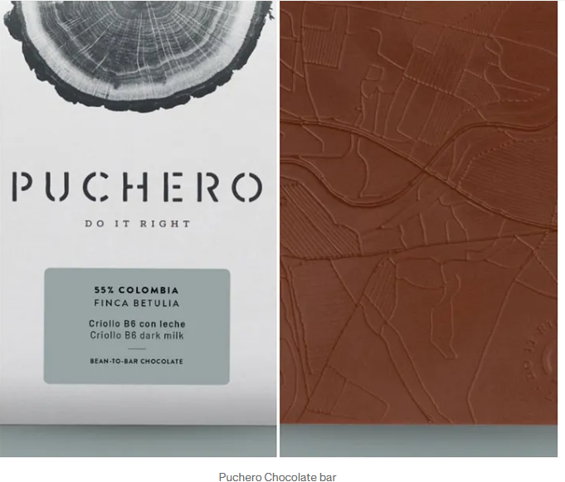

To confirm theory, we visited Puchero’s official website which is https://cocoarunners.com/shop/ and we found the company’s address from its socail media platform facebook

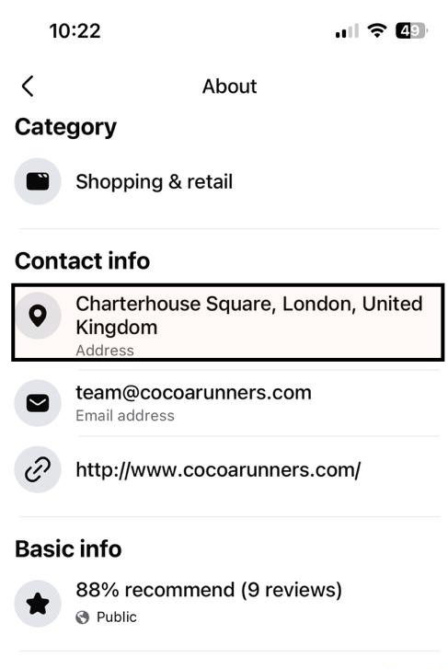

Using the address, We opened Google Earth Pro to get a closer look at the area. As we zoomed out and adjusted the view, the satellite image started to look strikingly familiar. it matched the one from the challenge image.then used Google Earth Pro’s timeline feature, which allows you to switch between historical and current imagery. The Geographycal location of the chocolate map is river Eresma and street N-601,and a right click on the location reveals the coordinates: 41.353471, -4.690148

